2520030297-Haadi Hasil
DBSE

Screenshot | Request | Expected status
1 | POST — Create student | 201 Created
2 | GET — All students | 200 OK
3 | GET — Student by ID | 200 OK
4 | PATCH — Update student | 200 OK
5 | DELETE — Delete student | 200 OK

1.
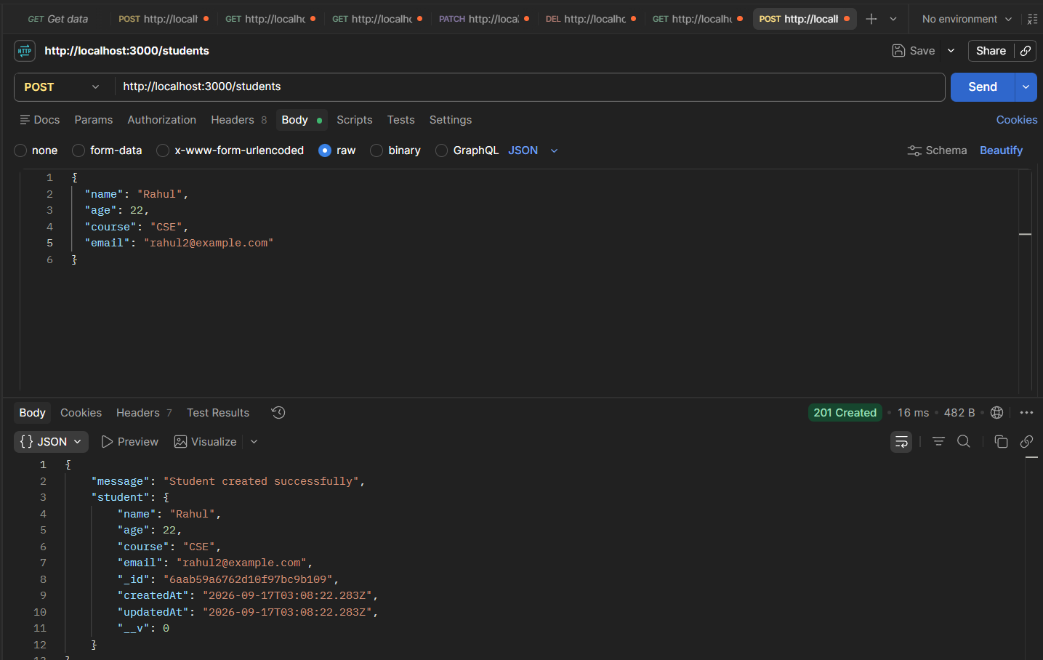
2.
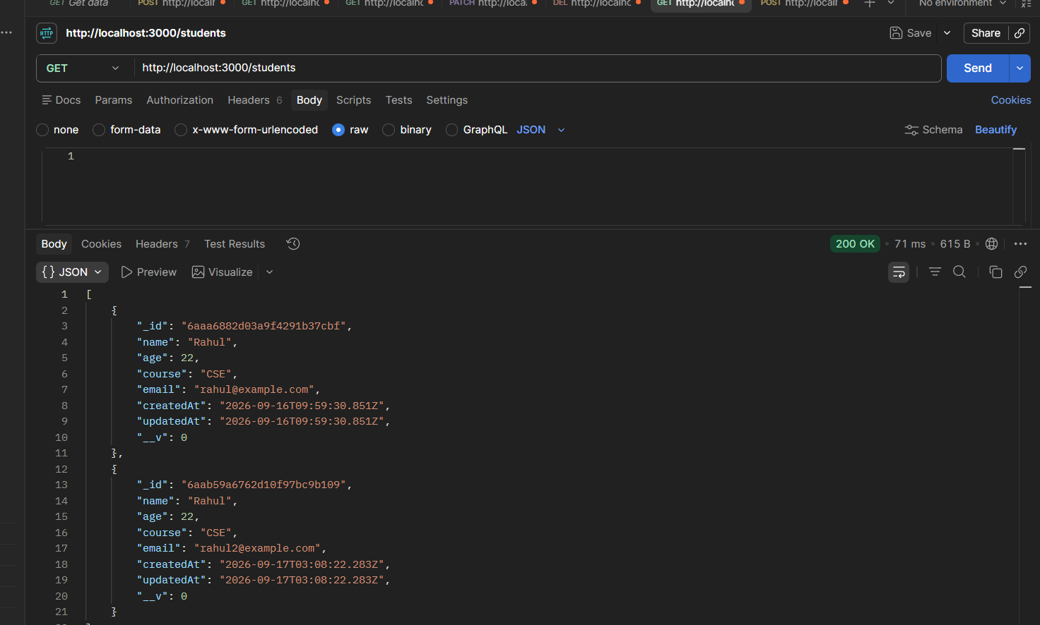
3.
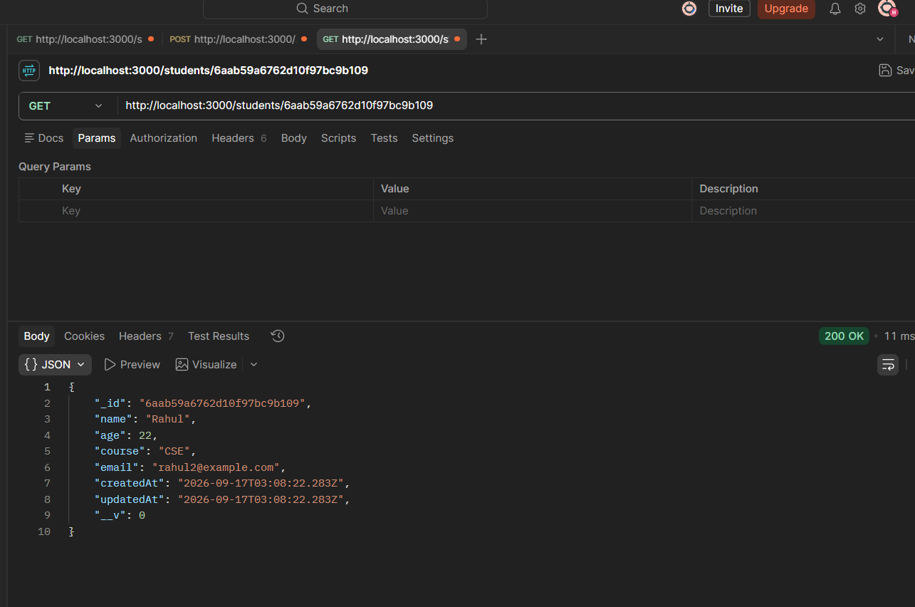
4.
5555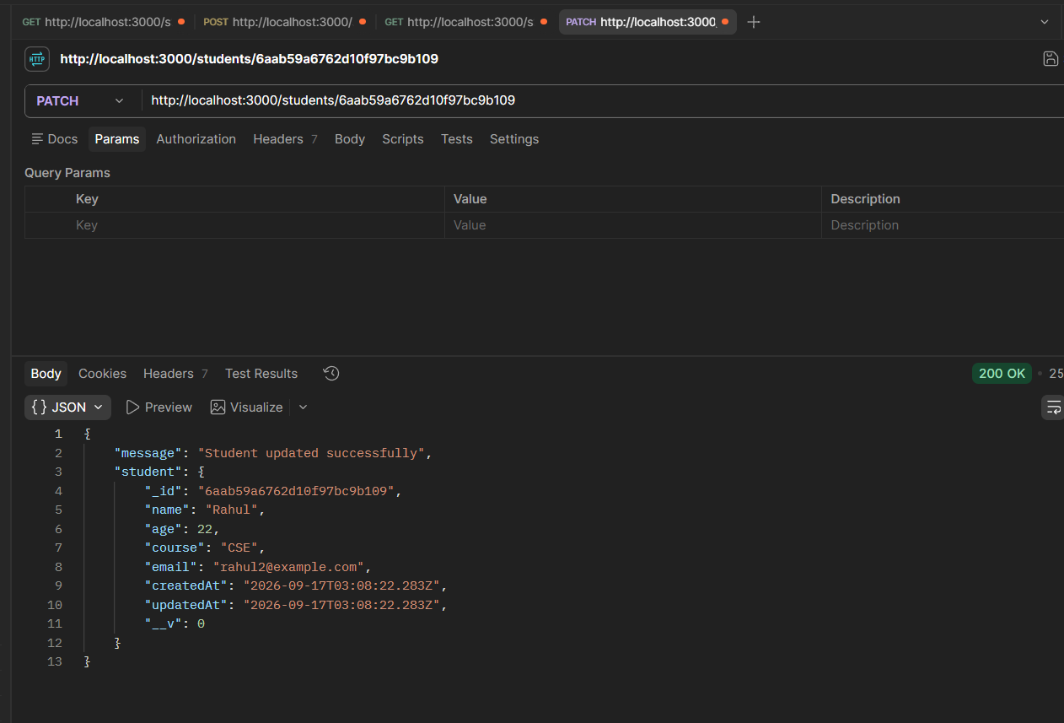
5.
